**Tri-Robot Cooperation**

**Milestone 02 Report**

*Zhaoyang Chen, Jieming Fan, Bingjie Zhu, Manqin Zhong*

**EECS 149 Fall 2019**

**GitHub repo:** <https://github.com/CZhaoYoung/EECS149-Group-project>

**Architecture:**

**(1) BLE communication.** Actor manipulates computer by pressing the start button or moving button to control the kobuki. Eventually, the command is sent to the leader of kobukis from the computer by BLE, and then the leader kobuki will advertise the commands by BLE to other kobukis to realize communication with each other.

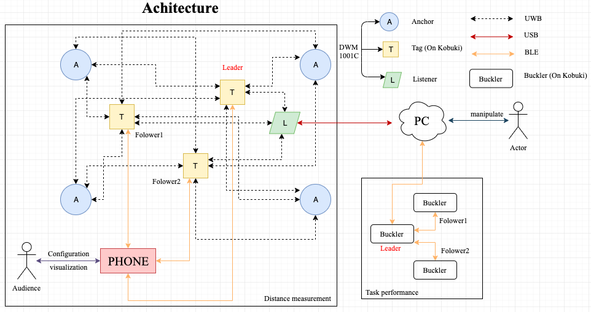

Figure 1: Architecture

**(2) UWB communication:**

We will utilize the UWB device (DWM 1001C) to form the distance measurement system to detect the distance between each kobukis. We apply the “ 4 anchors + 3 Tags + 1 Listener” system configuration option in our project, by configuring one of the devices as a listener device, the data can be captured to a PC directly.

**(3) Coordinate System Establishment.** As we have the data from the listener (DWM1001C), we can build a coordinate system by setting the location of the leader kobuki as an origin. The initial orientation of the kobuki can be obtained by pressing the start button to move the kobuki and then to get the vector, which can be regarded as the initial orientation of the kobuki.

**State machine :**

Leader kobuki receives the commands and enter *RUN* state. Then it will perform the action corresponding to the commands it receives. After that, the leader will advertise these commands to followers.

The followers who receive the commands will do actions just like the leader.

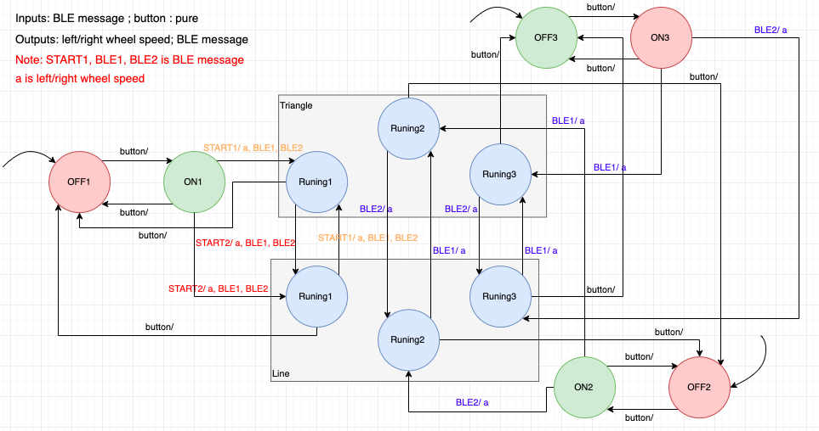

Figure 2: State machines for leader Kobuki and the followers

**Modifications to goals and project scope:**

* We set the *Kobuki performing route* to be:

Randomly place → Automatically forming a triangle (three Kobuki’s move without following the leader Kobuki )→Followers and the leader Kobuki do other commands of the instructor.

* We decided to use **8** ultra wideband transceivers, including 4 anchors, 3 tags and 1 listener to measure position of each Kobuki(i.e. its x,y,z coordinates).

**Progress so far:**

At milestone 2, we have made progress in:

* BLE communication
  + Between PC and leader Kobuki

We built a BLE service between computer and leader kobuki. The leader kobuki will receive advertisements from the computer and also advertise feedback to the computer.

* + Between leader Kobuki and the follower

We built the connections between leader Kobuki and the follower via BLE services.

We achieved the goal of BLE connection between PC and leader Kobuki. When the instructor press a key(up, down, left and right) and send commands via computer, the leader Kobuki will follow this command and also send them to its follower. At the same time, the follower will also follow the commands.

* Ultra wideband module
  + Network construction

We created a network of all transceivers in the Android mobile app.

* + Position the anchors

We set up 2 anchors(actually we need 4) and connected them with the mobile app through BLE

* + Device test

Due to lack of anchors, we used a one-tag-one-anchor system to test if the UWB transceiver works.

**List of necessary resources(code, parts, expertise, etc)**

Hardware:

DWM1001C ultra wideband transceiver*8, nRF52 Development Kit, Berkeley Bulker*3, Kobuki*3,

Software:

Buckler repo, BLE libraries, NRF SDK,

**Schedule of remaining time**

November 18-20: Apply for more UWB transceivers. Use PC terminal to configure the anchors and tags, create a 4-anchor-3-tag system (Bingjie & Zhaoyang). Prepare for the presentation materials, including video, screenshots, slides, etc.(Manqin & Jieming)

November 21: In-class presentation. (All)

November 22-25: Build the coordinate system to pin the position of each kobuki via PC terminal. Get the measurement of distance between two Kobuki’s. (Bingjie & Manqin) Create cooperation in the coordinate system, do some simple task testing (e.g. followers face the leader while receiving messages). (Jieming & Zhaoyang)

November 26 - December 2: Thanksgiving week. Let Kobuki’s perform the designed tasks via BLE(Zhaoyang & Jieming), testing time delay and drifts. (Bingjie & Manqin)

December 9: Final System testing, drift & time delay corrections.(All)

December 13: Finish demonstration video, posters and report preparation(All)

December 17: Final presentation and demo. (All)

December 19: Project report and video turned in. (Zhaoyang)

**Identification of major risks**

(1) We need to consider the drifts of each kobukis, which will be a tricky task in the coming weeks. It is challenging if the kobuki do not follow the route we set.

(2) The tag (DWM1001C) that is being tracked on the tablet must be in Bluetooth range of the tablet, if it is not on the range, it may not work well.

(3) We need to consider the time delay of BLE connections between the devices.